International Workshop  Journées d’études Toulousaines  Les interfaces en Sciences du langage  18-19 May 2017  Université Toulouse - Jean Jaurès  Campus du Mirail  Maison de la Recherche  5, allées Antonio Machado  TOULOUSE (France) | REGISTRATION FORM  Please email this form and a proof of payment to :  : contact.jetou2017@gmail.com  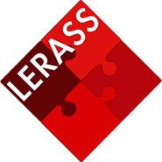  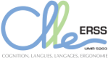

LAST NAME:...........................................................…… First name:............................................................
Occupation: ……….
University/Research center:……………………………………………………………………………………………………………………...
Postal address (home or office) .............................
…………
Email :…………………………………………………………. Tel.: ……………………………………………

will take part in the International JéTou 2017 Workshop on:

Thursday 18 May 2017
Friday 19 May 2017

Dinner:

will attend the dinner on Friday 19 May 2017 (+10 euros)

Please indicate any special dietary requirements: ………………………………………………………………..................

Payment:

Early bird (20/03/2017 – 17/04/2017) regular 30 €

Normal (from 18/04/2017) regular 40 €

Gala dinner (18/05/2017) 10 €
________________
Total ………€

Bank account information (cf. below).

Please provide a proof of the bank transfer you made.

Date: Signature :

Bank account information:
Payment by bank transfer in euros should be made out to:

M. l’Agent Comptable de l’Université Toulouse 2 - Jean Jaurès / Colloque JETOU2017

IMPORTANT: please don’t forget to indicate the following information: JETOU2017/Last name/M721C

